

German University in Cairo

Mechatronics Lab (MCTR704)

PUT HERE YOUR PROJECT NAME

Project No. [ ]

Members:

Name: ………………………………………… I.D. #:………..Group…..

Table of Contents

Mile Stone No. | Content | Page
1 | Automation Industry …….……………………………………………
1 | Description Diagram in 3D………………………………………..….
2 | Detailed Mechanical Components in 2D with Actual Dimensions
2 | Project Schematic Sequence of Operation ………………………
3 | Power Supply Components List ….……………….…….……….….
3 | Power Supply Circuit Diagram…..…………………….……….……
3 | Power Supply Circuit Description...……….………………...………
4 | Power Supply Face Plan as Implemented....……...…….…………
3 | Interface Circuit Components List ……………………………….…
3 | Interface Circuit Diagram………………………………….……….…
3 | Interface Circuit Description………...….…….……….…………….
5 | Interface Circuit Face Plan as Implemented……………….………
6 | Pneumatic Components List…………………………………………
6 | Pneumatic Circuit Diagram…………………………………………..
6 | Pneumatic Step Diagram and Description…..…………………….
7 | PLC Sequence Chart ……………………………………………….

Automation Industry

Generally explain the major technology components used in automation industry with block diagram and examples

Description Diagram in 3D

- draw the project in 3D with any software tool and explain its operation
- explode the mechanical 3D and Give a number for each mechanical part
- Fill in the table showing the part number and its name

Part number | Name

EXAMPLE
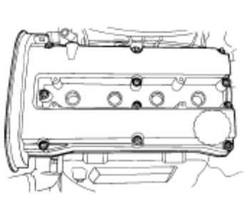3D Drawing
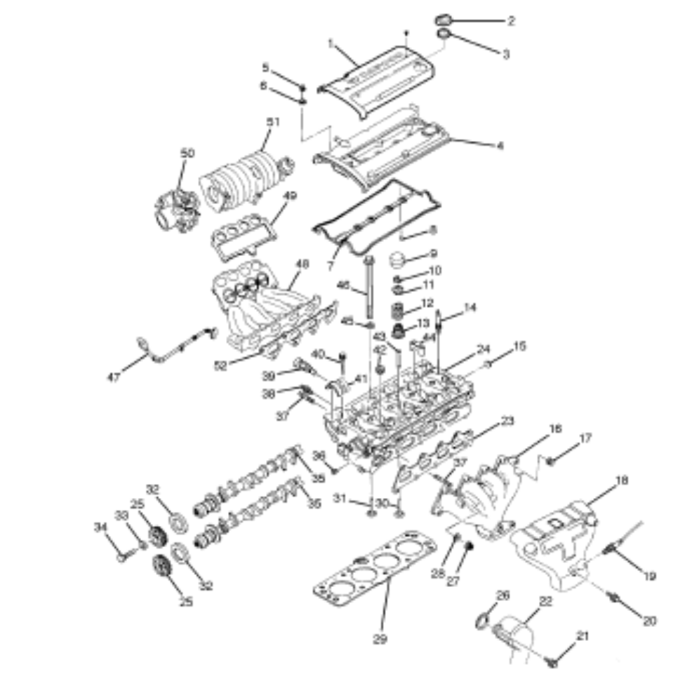
3d drawing exploded

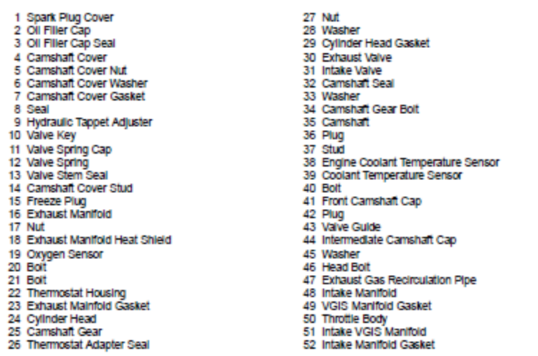

Table for each part

Detailed Mechanical Components in 2D with Actual Dimensions

- Each part in the project is considered as a component, even the nut and screw and each component will be explained in a separate row in the table shown below.

Fill in with the Part Name and number as given in the 3D
Area for Drawing in in 2D (with dimensions )

Fill in with the Part Name and number as given in the 3D
Area for Drawing in in 2D (with dimensions )

Extend the table for your entire components list

Project Schematic Sequence of Operation

- Show the project sequence of operation in a schematic form as explained to you.

Example

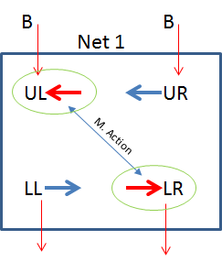

Power Supply Components List

Item | Component Description | Symbol | Circuit Location | Face plan Location
1
2
3
4
5
6
7
8
9
10

- The power supply will provide your project actuatiors with the required voltage for operation as for example if your consists actuators operational voltage is 24VDC , then your power supply should provide this output voltage

- Fill in the table with the components used in your design
- Item………….. is serial number for the table rows
- Component description ………..is the name of the component for example resistance
- Symbol………… The component symbol………eg. R₂
- Circuit Location……..location in circuit diagram eg. B/4
- Face plan Location …………. location in Face plan diagram eg. C/3

Power Supply Circuit Diagram

- Design and draw your project power supply circuit, the power supply circuit will be used for feeding the project actuator with the voltage required.

- On this page put in the circuit diagram in the frame with the tag of the project name, date and version no.

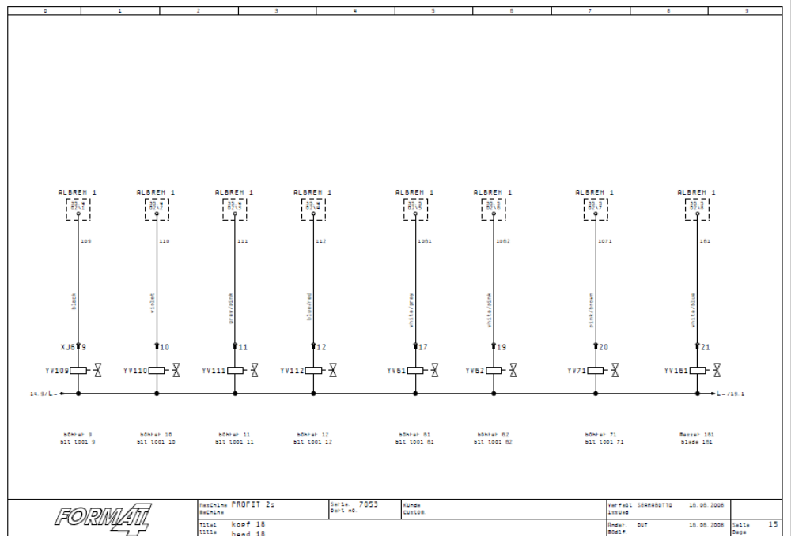

- Example for circuit diagram with the required frame

Power Supply Circuit Description

- Explain how the circuit functions, your explanation should be in small sentences in bullets

- Show by drawing the test point’s (P1, P2, …….etc ) signals at different states of the circuit diagram as explained to you.

Power Supply Face Plane Diagram

- Insert the power supply face plan as explained for you

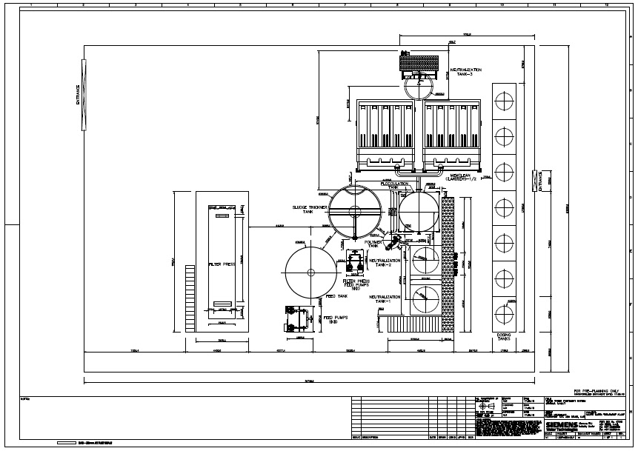

- Example of face plan

Interface Circuit Components List

Item | Component Description | Symbol | Circuit Location | Face plan Location
1
2
3
4
5
6
7
8
9
10

Interface Circuit Diagram

- Design and draw your project INTERFACE circuit, the circuit will be used for
- Receiving input and output digital signals from the PLC.
- Connecting the power supply voltage to the actuators via the relays contacts.
- Feeding sensors and input devices direct from the PLC.

- Put in the circuit diagram in the frame with the tag of the project name, date and version no.

Interface Circuit Description

- Explain how the circuit functions, your explanation should be in small sentences in bullets

Interface Circuit Face Plane Diagram

Pneumatic Components List

Item | Name and Description | Symbol
1
2
3

- In the above table, fill in with the pneumatic components that you select for designing the pneumatic circuit

Pneumatic Circuit Diagram

- Draw and simulate the pneumatic circuit by using the fluidSim software application ( down load this software from the internet)

Pneumatic Step Diagram and Description

- Draw the pneumatic step diagram .as shown in the below example

- Example for the pneumatic step diagram

- 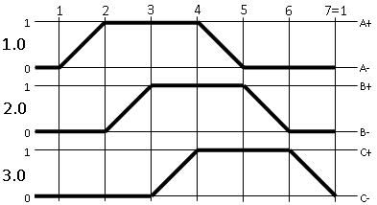

PLC Sequence Chart

Draw your project PLC sequence diagram
Example

